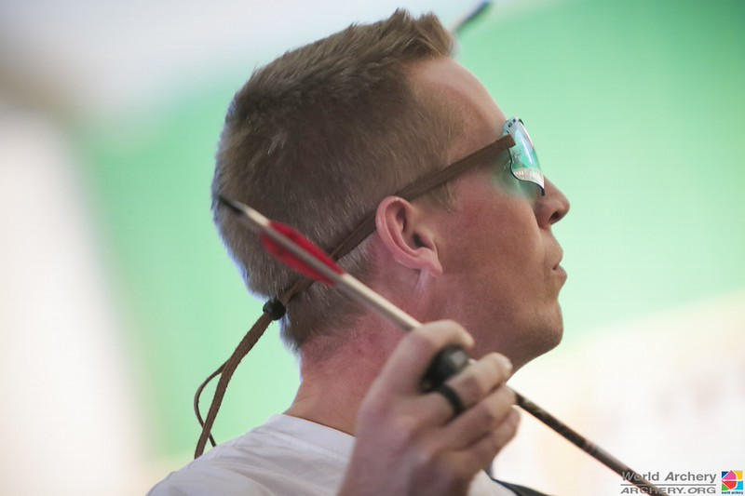

Ed Mc Dermott and Nicky Hawkins had a Jollys away day on Saturday. They shot in the first stage of the Indoor World Cup at Marrakesh. Ed is pictured on his way to 17th place overall after 15th place in the qualifying round finishing ahead of the 2nd ranked British archer Alex Smith. Nicky came 41st just missing out on the Head to Head phase. In the Head to Head Ed met Yagiz Yilmaz from Turkey who is ranked 64th in the World and in a close match lost 6-4. The detailed results are on www.worldarchery.org.

There are three more indoor events in Bangkok, Nimes, and Las Vegas. Better get their next holiday booked!!